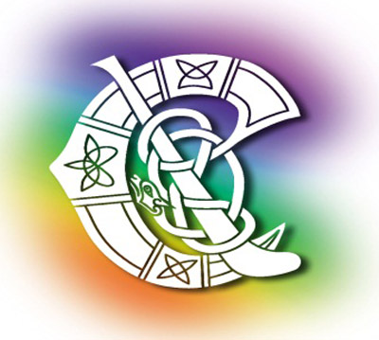
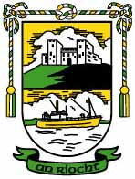

Child Protection & Vulnerable Adults
Policy Statement

An Riocht is committed to creating and maintaining the safest possible environment for all young people who wish to participate in our Gaelic Games and activities. We shall take all practicable steps to protect them from discernable forms of abuse, from harm, discrimination or degrading treatment and shall respect their rights, wishes and feelings.

We do this by;
• Recognising that all children and vulnerable adults have the right to be protected from harm.
• Ensuring that all our coaches and volunteers are carefully recruited and selected and that they accept responsibility for ensuring the wellbeing of children and vulnerable adults in their care.
• Responding swiftly and appropriately to protect the welfare of children and vulnerable adults who participate in our games and related activities.
• Providing parents, children, and vulnerable adults with the opportunity to voice any concerns they may have.
• Appointing Children’s Officers in each of our Clubs and at County Board level.
• Appointing a National Children’s Officer to oversee the implementation of good child protection and welfare practices within the Association.
• Appointing a Designated Person in each Club and County who will liaise with the statutory authorities as appropriate.
• Appointing a National Designated Person to assist in the processing of child protection and welfare matters.
• Ensuring that all allegations of abuse of young people, and vulnerable adults, are confidentially dealt with in accordance the Associations Guidelines for Dealing with Allegations of Abuse (Fourth Edition 2009) and with statutory guidelines and relevant legislation.
• Reviewing the effectiveness of our Child Protection and Welfare procedures and policies on an ongoing basis.
• Ensuring that members, coaches, team mentors, administrators, parents/guardians and spectators
sign-up to and adhere to our Code of Behaviour.
The Committee of AN RIOCHT commit to ensuring that we follow the Association Code of Best Practice in Youth Sport and the Association Code of Behaviour for all Persons Working with Young People and Vulnerable Adults. We have nominated the following people in the position of Childrens’ Officer and Designated Person respectively. Full training has been provided in order to ensure full implementation of the club Child Protection and Welfare Policy.
Signed Shona McConville Children’s Officer
Signed Jim Sloan Designated Person
Signed Jim Sloan Chairperson
Signed Gavin Finnegan Secretary

