**An Ríocht Club Policy on Gambling**

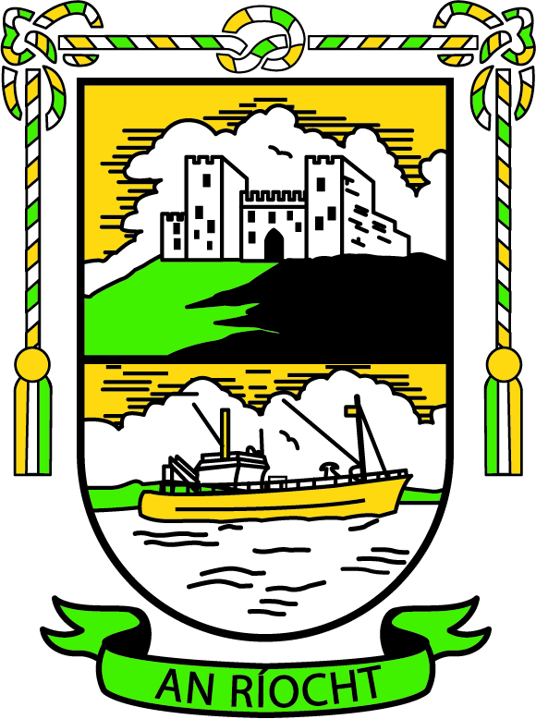

1. **Introduction**

The An Ríocht Club has developed this Gambling Policy:

1. to support the health and wellbeing of its members;

2. to protect the integrity of our games and our players;

3. to provide a positive example in breaking the growing societal link between sport and betting.

In developing the policy, the Club Executive has considered:

• Our duty of care towards our members, particularly our players and juvenile members who, research shows, are at a higher risk of harmful gambling

• Local community and wider societal concerns regarding harmful or problem gambling

• GAA rules and regulations

• Relevant national law

**2. Policy commitments:**

The An Ríocht Club will ensure that:

• No betting-related sponsorship is accepted for club teams, gear, property, or equipment.

• All officers, players, mentors, and members are aware that GAA Rule 1.15 prohibits players, team management or match officials from betting on games in which they are involved; and that they are aware of the consequences of violating this rule (minimum sanction members face for offence is an eight-week suspension; expulsion from the Association may also be considered in some cases.)

• The club upholds GAA Rule 5.8: Bookmaking shall not be permitted within Association property. (A member breaching or aiding the breach of this rule will be suspended for 24 weeks.)

• Club communication channels (such as websites, social media platforms, Club Whatsapp groups) are not used to promote or discuss betting odds or to carry any related advertising and that appropriate steps are taken should this directive be violated.

• The Club Lotto is managed in a responsible manner, is adherent to the law, and is not open to juvenile members.

• The GAA’s Gambling Awareness resources are made available to all players and members through our communication platforms.

• Gambling awareness educational opportunities, such as the GAA’s own gambling awareness presentation or that offered by a reputable external entity, is made available to all playing members from the age of u17 upwards at least once a year.

• This policy is reviewed by the Club Executive every two years or in the aftermath of any official GAA rule change or directive that impacts on it.

Signed:

Tara Campbell

Club Chairperson

Date: 1st February 2019

**Gambling and Sport – Considerations for the GAA**

Recommendations and advice regarding gambling for GAA clubs, their players and their members

Problem gambling is becoming a growing concern in modern Ireland. As part of the GAA’s on-going work in relation to the welfare of our players and our members it is deemed timely to prepare for our clubs a set of basic guidelines that address the key issues relating to this concerning development.

This document aims to assist GAA members in identifying what problem gambling is and to encourage those who may be experiencing a difficulty to seek support and assistance. It also highlights the strict regulations and consequences – both within GAA rule and the broader laws of the land – regarding match-fixing or the use of insider information for the financial gain of the individual or team concerned, or any third parties involved.

The material has been prepared with the assistance of the professional counsellors who operate the GPA’s counselling service, Colin O’Driscoll, PsSI registered psychologist and addiction specialist, and the Gambling Aware website [www.gambleaware.ie](http://www.gambleaware.ie)

**Knowledge and caution are your best bets**

For a large portion of the Irish population gambling is a recreational pastime that causes no significant immediate or long terms issues. However, harmful or problem gambling is on the increase across the 32 counties. As the island’s largest sporting and community organisation this is reflected in the membership of the GAA amongst players and non-players alike.

**What is harmful or problem gambling?**

If you suffer from adverse consequences as a result of your gambling yet continue to participate in the act you could be said to be engaged in harmful or problem gambling. (Some of these potential negative consequences are outlined below under ‘How do you recognise problem gambling?’)

Gambling addiction can be described as an ‘impulse control problem’ that any person can suffer from regardless of age, sex or socio-economic profile. This means the individual often feels compelled to engage in this behaviour despite a desire to stop.

**What are the facts and figures?**

In a recent survey of all 2,045 current GPA members, 7% of members believe that there is a gambling problem within their own squad but 23% believe that there is a gambling problem amongst GAA players generally. In other words players think there is a problem, just not in their own squad.

During 2012, gambling addiction accounted for one third (33%) of the cases dealt with by the GPA’s free counselling service for members, and this figure is expected to increase as awareness grows. While the players who participated in the above survey and who received treatment for gambling addiction through the GPA are all inter-county players, it’s important to remember they are club players also.

**Statistics related to gambling and the general Irish population (taken from** [**www.gambleaware.ie**](http://www.gambleaware.ie)**).**

• Approximately 2% of Irish adults gamble online regularly.

• Approximately 12% of Irish adults bet with a bookmaker weekly.

• Less than 1% of those who need treatment for problem gambling actually receive it.

• Irish people are estimated to gamble over €5bn per year; that’s €14m per day or €10,000 per minute.

• According to the Institute of Public Health in Ireland, adolescent gambling is thought to be 2-3 times the rate of adults.

**How do you recognise problem gambling?**

Answering yes to some of these questions does not necessarily make you a problem gambler but may indicate a problem.

• Do you sometimes spend more money and time on gambling than you can afford to?

• Do you find it hard to stop or manage your gambling?

• Do you have arguments with family or friends about money and gambling?

• Do you always think or talk about gambling?

• Do you lie about gambling or hide it from other people?

• Do you chase losses or gamble to get out of financial trouble?

• Do you borrow money, sell possessions or do not pay bills in order to pay for gambling?

• Does your gambling cause you to neglect personal, professional, or family responsibilities?

• Do you feel anxious, worried, guilty, depressed or irritable because of gambling?

• Do you gamble to escape worry, trouble, boredom or loneliness?

• Do you have difficulty sleeping because of gambling?

If you worry that you may be engaging in problem gambling it may be important to speak to someone you trust immediately. Testimonies from inter-county and club stars such as Armagh’s Oisin McConville and Offaly’s Niall McNamee highlight the sense of relief felt by someone experiencing problem gambling once they finally reach out. Help is at hand and problem gambling can be treated effectively.

**Gambling and your sport**

As a player, mentor, or official with a unique insight into team selection, tactics, form, or insider information, the best recommendation is to never bet on a competition your team is involved in. Legislation in Ireland and Northern Ireland outlines severe consequences relating to any potential match-fixing or abuse of insider knowledge, with penalties including a fine and/or imprisonment.

Within the GAA, match-fixing or improperly influencing the outcome of a game for your financial gain or another’s could fall under ‘Misconduct considered to have discredited the Association’ dealt with under Rule 7.2(e) in the Official Guide 2013. Penalties for individuals or teams/units range from a minimum 8-week suspension to debarment and expulsion from the Association.

**Key Points and Guiding Principles**

1.Know the rules regarding sport and betting

2. It is safest to never bet on a competition your team is involved in

3. Be careful about handling sensitive information

4. Fixing any part of an event is against the laws of the land and the Association

5. Report any approaches made by third parties

**Remember:** match fixers will be caught and all suspicious bets are monitored.

If you or someone you know is having difficulties relating to gambling or you feel you need help to address your gambling behaviour contact your local GP, a psychologist, or an addiction specialist. You can also call the National Gambling Helpline on 1800-753-753 (ROI) or 0808-8020-133 (NI).