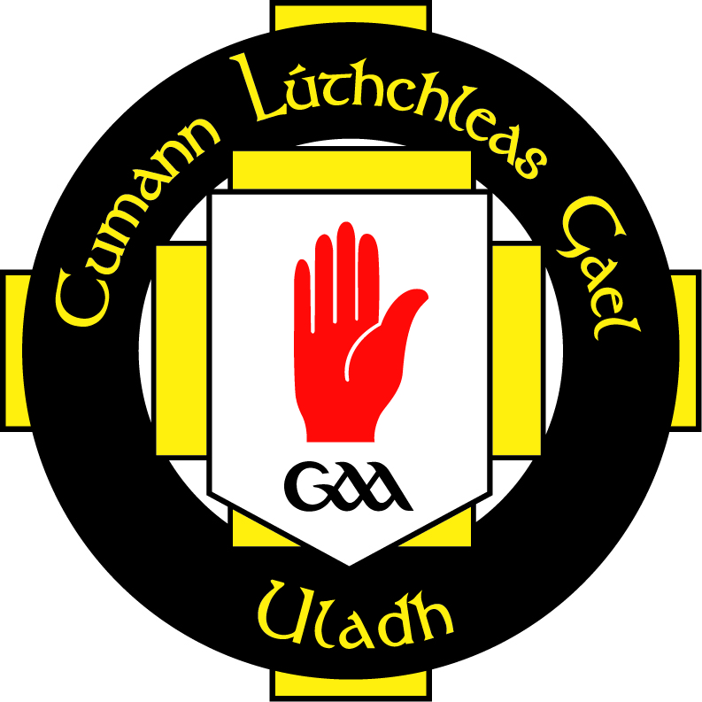

RECRUITMENT POLICY

To ensure that this club is following best practice we shall work closely with the Down County Board and Ulster GAA. We shall comply with the guidelines of the Code of Ethics and Good Practice for Children’s Sport, and the GAA Code of Best Practice in Youth Sport.
We will follow recommendations made by our governing body of sport that stipulate our volunteers should undergo a recruitment process. The following procedures for recruitment of volunteers will assist in placing volunteers in a situation to which they are suited and help in the protection of children and volunteers alike.
- List all tasks that volunteers need to perform and the skills needed for those tasks
- Provide training for volunteers in their role by urging them to attend Ulster GAA Club Maith Officer Training Programme, and additional training where deemed necessary.
- Make vacancies within the club openly available to interested and qualified applicants
- An application from should be completed by each applicant
- There is an onus on the Club Children’s Officer(s) to ensure that all volunteers / coaches who have substantial access to children regardless of whether they are paid or not, to have their background checked.
- References should be verified by the Club Executive Committee and should be kept on file for record
- All recommendations for member appointment should be ratified by the club’s Executive Committee. The decision to appoint team managers is the responsibility for the club Committee and not any one individual within it.
- Once recruited into the club, all volunteers should be adequately managed and supported.
- Ulster GAA would recommend that volunteers should be given an induction period for two months, after which the Club Executive Committee have the power to remove a person from a role should they be deemed unsuitable.
- Any statutory guidelines should be adhered to

This document has been approved by the Club Executive Committee and serves as the working recruitment policy document of AN RIOCHT

Signed (Rúnaí ) G Finnegan
Signed (Cathaoirleach) J Sloan

