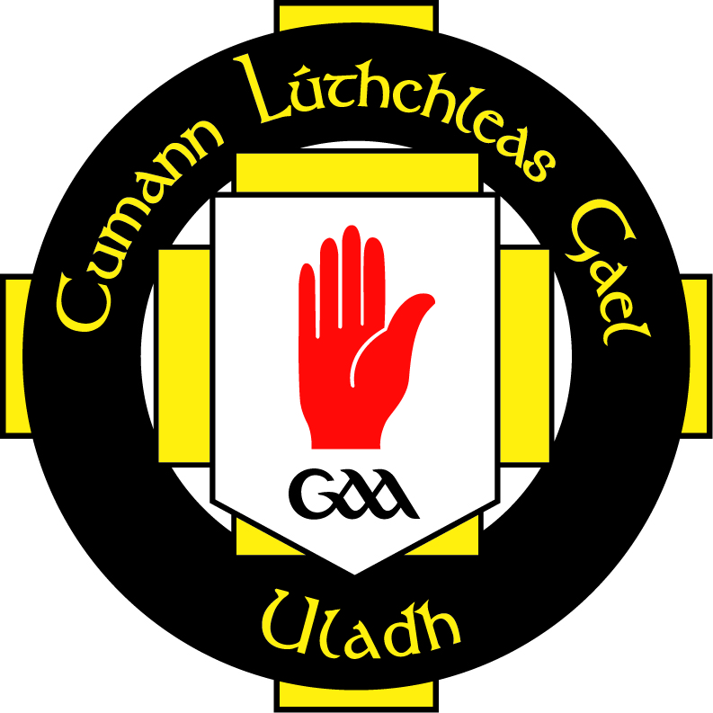


Senior Players
Code of Conduct

AN RIOCHT is fully committed to the safeguarding and promoting the well being of all its members. The club believes that it is important that senior players associated with the club must, at all times show respect and understanding for the safety and welfare of everybody. Therefore they are encouraged to be open at all times and share any concerns or complaints that may have with their respective Team Coach or Club Officials.

Players must:
- Respect the rights, dignity and worth of all and treat everyone equitably.
- Not exert undue influence to obtain person benefit or reward.

Players within the Club must:

  - Play by the rules

  - Never argue with an official. If you need clarification, have your captain, coach or manager approach the official during a break or after the competition.

  - Work equally hard for yourself and your team. Your team’s performance will benefit – so will you.

  - Be a good sport. Applaud all good plays whether they are made by your team or the opposition.

  - Show respect to and acknowledge opponents and officials (e.g. shake hands before and after the game and say things like “good luck”, “thanks for the game” etc.)

  - Cooperate with your coach, team-mates and opponents without them there would be no competition.

  - Be on time for training sessions, matches and competitions so as not to disrupt the smooth running of the team.

  - Participate for your own enjoyment and benefit not just to please parents and coaches.

  - Play fair, no verbal abuse of officials, sledging other players (including vilification) or deliberately provoking an opponent.

  - Respect the rights dignity and worth of all participants regardless of their gender, ability, cultural background or religion.

Rule 7.2. Helmet/Facial guard
In all Camogie games and training sessions it is mandatory for all players to wear an approved, i.e. NSAI Standard IS355, helmet with facial guard. Please click on link.
Camogie-GAA-Helmet-Safety-Information.pdf

Mouthguard
Since 2013, the GAA introduced the rule that all players in all grades must wear a mouthguard or gumshield in both Gaelic football and Ireland – training and games. Please click on link.
PRESS RELEASE (gaa.ie)

Declaration

I understand and agree to abide by this Code of Conduct. I understand that failure to abide by this Code of Conduct will result in disciplinary action by the club committee.

Signed:______________________________________ Date:__________________

