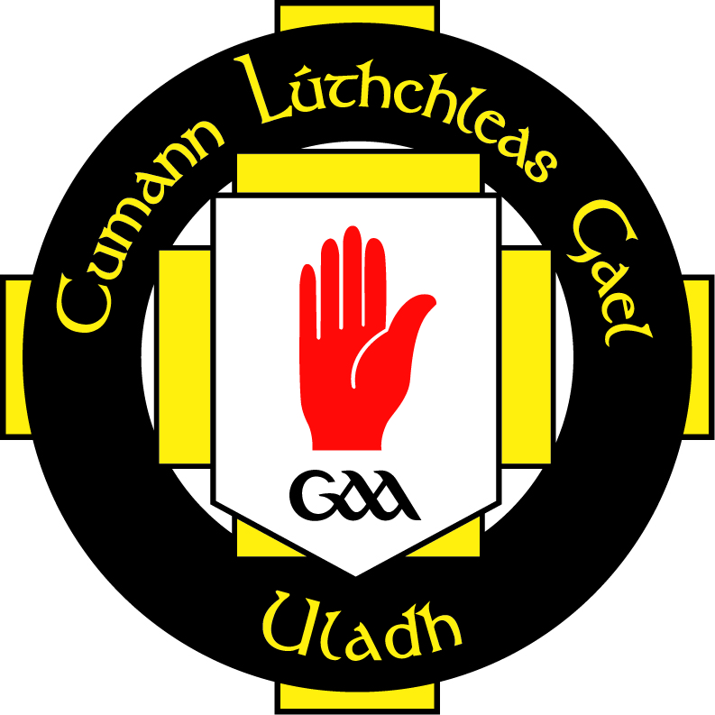
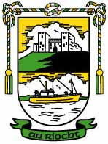

Code of Expectations for Parents Policy

AN RIOCHT adapts a child centred approach and philosophy in the running of the club to ensure that those working with children and young people are at all times provided a quality sporting and social programme, by working to an agreed philosophy and set of standards. Enforcement of this conduct is the responsibility of every member and any queries about this code should be referred to the Children’s Officer, Designated Person, or the Club Chairperson

Parents/guardians have an influential role to play in assisting their offspring to adopt positive attitudes and encouraging them to maintain an involvement in sport. Parents should not attempt to meet their own needs for success and achievement through their children’s participation in Gaelic Games. The following guidelines will be assistance in their regard:

Parents/Spectators within the Club must:

  - Attend games on a regular basis assist in their organisation of club activities.

  - Remember that children participate in sport for their enjoyment not yours.

  - Encourage children always to play according to the rules and to settle disagreements without resorting to hostility or violence.

  - Never ridicule or yell at a child for making a mistake or not winning.

  - Respect officials decisions and encourage children to do likewise.

  - Show appreciation for volunteer coaches officials and administrators.

  - Applaud good performance and efforts from all individuals and teams.

  - Congratulate all participations regardless of the game’s outcome

  - Condemn the use of violence, verbal abuse or vilification in any form, whether it is by spectators, coaches, officials or players.

  - Support policy and practices (and lead by example) in relation to responsible use of alcohol, to child protection issues and to issues involving recreational and performance enhancing drugs.

  - Support involvement in modified rules games and other junior development programmes

  - Respect the rights, dignity and worth of every young person regardless of their gender, ability, cultural background or religion.

Rule 7.2. Helmet/Facial guard
In all Camogie games and training sessions it is mandatory for all players to wear an approved, i.e. NSAI Standard IS355, helmet with facial guard.
Camogie-GAA-Helmet-Safety-Information.pdf
Mouthguard
Since 2013, the GAA introduced the rule that all players in all grades must wear a mouthguard or gumshield in both Gaelic football and Ireland – training and games.. Please click on link.
PRESS RELEASE (gaa.ie)

I understand and agree to abide by this Code of Conduct. I understand that failure to abide by this Code of Conduct will result in disciplinary action by the Club Executive Committee.

Signed (Parent/Guardian):__________________________ Date:_________

Signed (Parent/Guardian):__________________________ Date:_________

Signed: . Date:_________
Football Coaching Officer – Deaglan O’Reilly

Signed: . Date:_________
Camogie Coaching Officer – Thomas Sloan

Signed: . Date:_________
Chairperson - Jim Sloan

