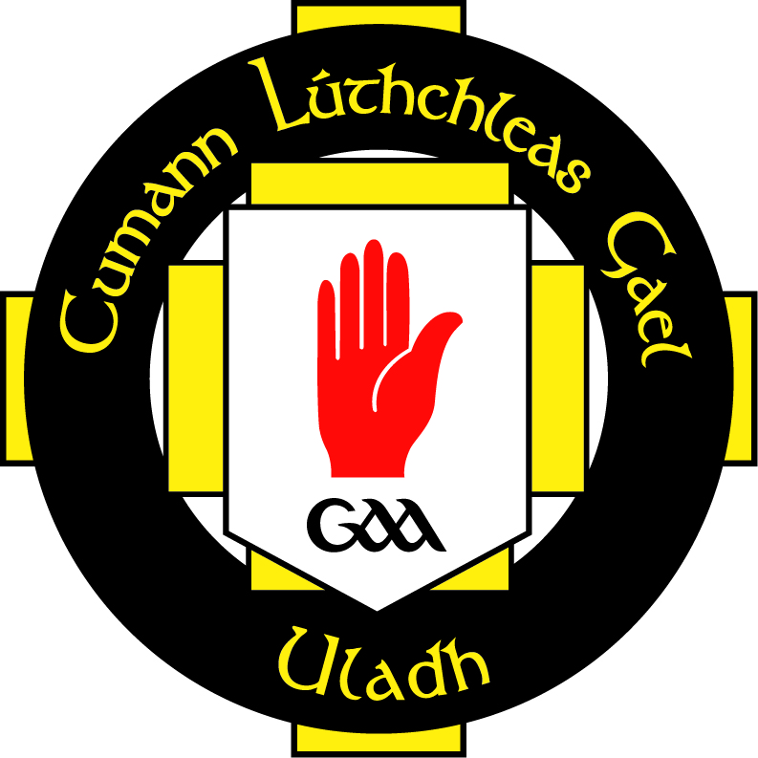

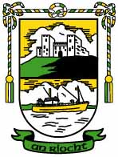

**Club Database Guidelines**

The club complies with the requirements of the Data Protection Act 2018 with regard to the collection, storage, processing and disclosure of personal information and it is committed to upholding the Act’s core Data Protection Principals.

The club strives to ensure that it keeps a comprehensive set of data on all its members. This information is stored online via the GAA approved Foireann system. The club should ensure that it stores information on the following groups within the club:

**Non-Playing Members**

The information that should be stored on all non-playing members is as follows:

* Names / Address / Date Of Birth / Occupation
* Home Tel Number / Work Tel Number / Mobile Tel Number
* Special Medical Conditions

**Players**

The information that should be stored on all members is as follows:

* Name / Address / DOB
* School (if applicable) / Occupation (if applicable)
* Home Tel Number / Mobile Number / Emergency Contact
* Special Medical Conditions / Previous Sports Injuries
* Parents/Guardian name (if underage)

**Club Officials**

Information is stored on all club officials, both Executive Committee and all sub-committee members. The information stored is followed:

* Name / Address / DOB
* Occupation / Role within club
* Home Tel Number / Work Tel Number / Mobile Number
* Special Medical Conditions
* Administration Courses Attended

**Club Coaches**

There is information stored on all coaches.

The information that should be stored on club coaches/volunteers is as follows:

* Name / Address / DOB
* Occupation
* Home Tel Number / Work Tel Number / Mobile Number
* Special Medical Conditions
* Actively Coaching? / Team Coached
* Coaching Qualifications and Dates Achieved.
* Ulster Council and CPD Qualifications
* Child Protection Qualifications / First Aid Qualifications
* Other relevant qualifications (and dates)

### PHOTOGRAPH CONSENT FORM

**AN RIOCHT** feel it is important to recognise the achievements and successes of our youth and of the club as a whole. One of the ways to do this is to publish photographs and details of achievements in our local press and on social media / club website.

We take the issue of child safety very seriously and this includes the images of the children in our care. We therefore require photo consent from parents when completing registration on Foireann on behalf of their children and require consent from individual adult members. We ensure compliance under the child protection policy and Data protection legislation.